

Midterm Project

Topic: Digital Wallet Application

Lecturer : So Vengleab

Course: Mobile_App_Development_II

Year: IV

Semester : II

Academic Year : 2021 – 2022

By Group Member :
Mr. Oum Soknang(Leader)
Mr. Koiy Bottra(Deputy)
Mr. Chhay Lang

Date : 05 / 07 / 2021
Report

What is the project about?

- This Application is about digital wallet app that user can freely transfer money, top up money, bill payment ect… and can use anywhere when we have internet.
Why we choose this topic?

- We choose this topic for 2 main reasons:
1, Problem: sometime we can’t bring a lot amount of money with us because invite problem like robber or forgetting.
2, Solution: So whit this application we don’t worry any more problem keeping money or robber and even we lost it we can backup account to use again.

What is our goal of making this happen?

Our Goal:
We don’t expect to finish this application to full functionality of app that in the UI, so we will skip some feather in app that we can’t make. And we can specific which function for now because we will try our best hope teacher understand.

Our team members working in project:

Oum Soknang:
- Team leader (Maintenance, coding, general management in project)

Koiy Bottra:
- Team Deputy (Research and Database)

Chhay Lang
- Member (Prepare document and any task when needed)

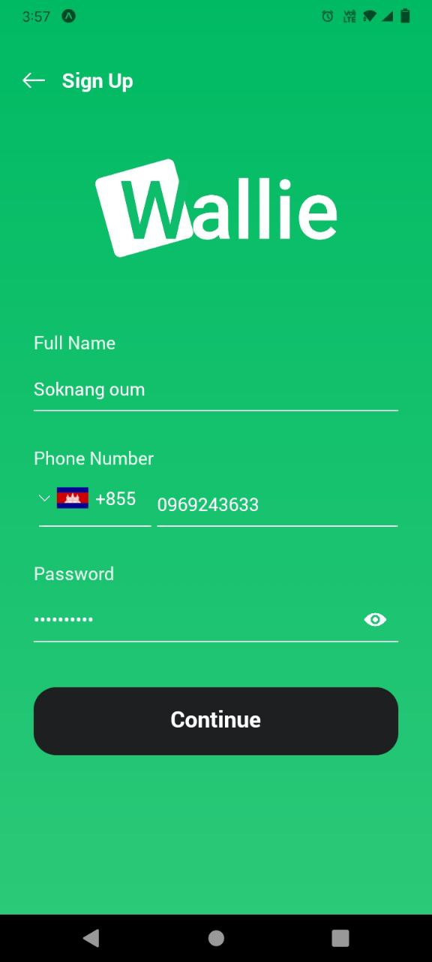
Our Platform

- Frontend
+ Sign Up Screen:
This screen we can sign up user and nationality around the world.
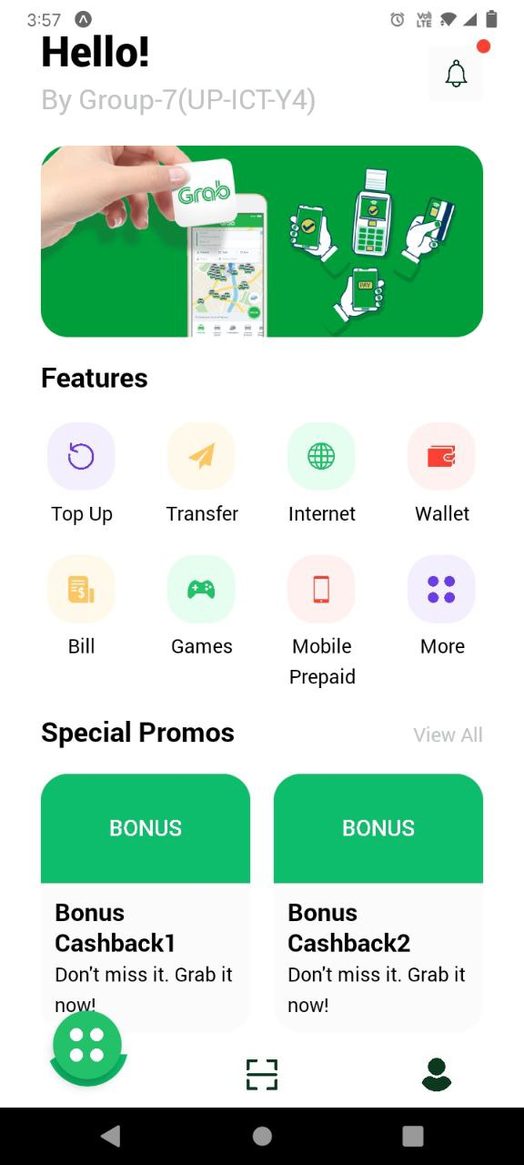
+ Homescreen:
This screen show all functionality of the our application but until the final we can’t say that we can complete with the Feather function but we will try our best as we can.
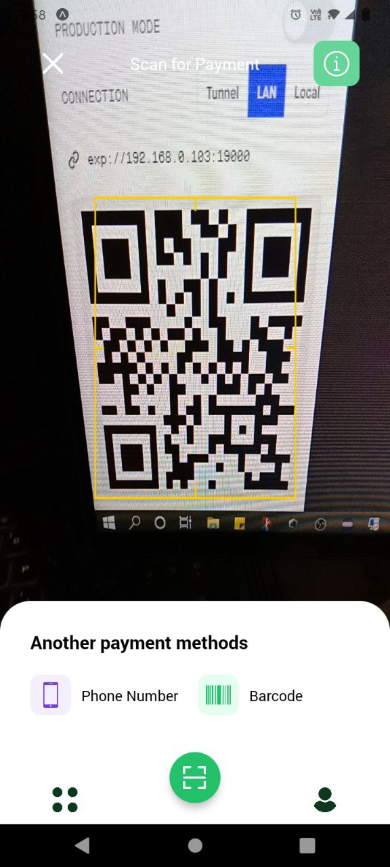
+ Scan Payment Screen:
This screen we can scan payment with camera, Phone Number, and Barcode.
Phone Number and Barcode we don’t think we can finish because we expecting to do function in the home page first, so we can’t can finish until final.


Website references and YouTube link

https://www.youtube.com/watch?v=rcXyN_cfGY8&ab_channel=ByProgrammers

https://www.google.com/url?sa=i&url=https%3A%2F%2Fcommons.wikimedia.org%2Fwiki%2FFile%3AFlag_of_Cambodia_(four_towers_Angkor_Wat).jpg&psig=AOvVaw1rRCc9AcpEw_fLnVSbnyEG&ust=1625651495604000&source=images&cd=vfe&ved=0CAoQjRxqFwoTCNjs1PGVzvECFQAAAAAdAAAAABAD

https://psd-template.com/blog/wallie_digital_wallet_app_ui_kit/2020-05-19-15962

https://restcountries.eu/#api-endpoints-all

https://www.countryflags.io/

 The End 

